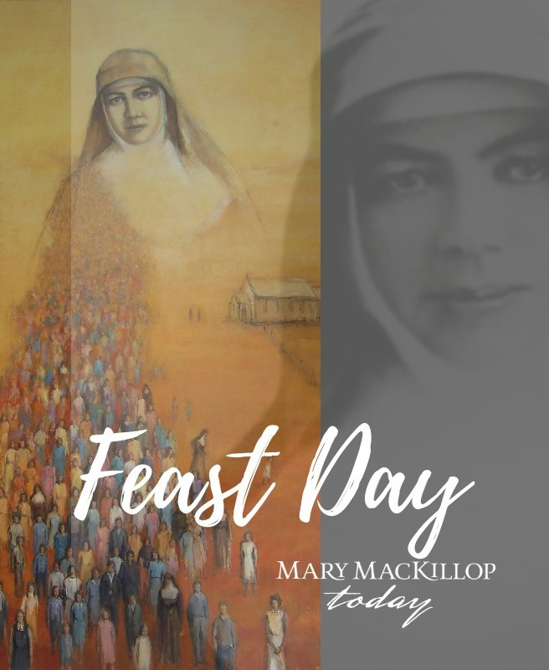
Thank you for your prayers
Mary MacKillop Today supports thousands of people in Timor-Leste, Peru, Papua New Guinea, Fiji and here in Australia, bringing hope to communities for generations to come.

Please pray for Mary MacKillop Today especially during the challenging times we all face, so that we can continue to transform lives through our vitals works
carrying on the legacy of Saint Mary MacKillop.

If you’d like to learn about Mary MacKillop Today please contact us via Ph: (02) 8912 2763
Email: hello@marymackilloptoday.org.au or visit:

www.marymackilloptoday.org.au

