Continuing Saint Mary MacKillop’s legacy
Mary MacKillop Today supports thousands of people in Timor-Leste, Peru, Papua New Guinea, Fiji and here in Australia, bringing hope to communities for generations to come.
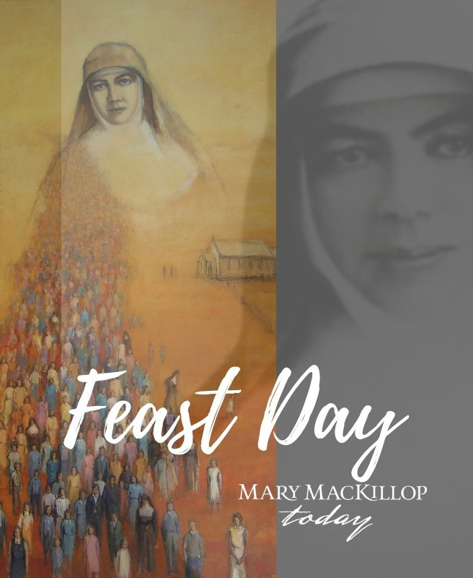
Inspired by Australia’s first saint, we are working to transform lives with dignity for self determination.
Scan this code to sign up to hear more about the work we do.

www.marymackilloptoday.org.au

