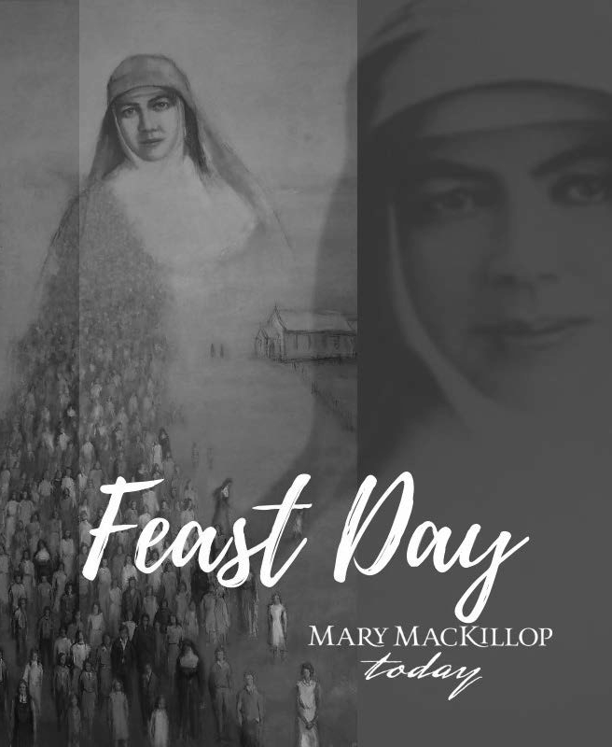
In the spirit of Mary MacKillop, we invite you to bring life to
“the poorest and most neglected parts of God’s vineyard.”

Your donation to Mary MacKillop Today will support thousands of people in Timor-Leste, Peru, Papua New Guinea, Fiji and here in Australia with education, health and finance and livelihoods opportunities, bringing hope to communities for generations to come.
To make a donation please go to:

www.marymackilloptoday.org.au/donate

Or contact us at: Mary MacKillop Today
PO Box 1646 North Sydney NSW 2059 Ph: 02 8912 2763

